# Algorithm for EKG transform

There is one EKG file per mouse. The application needs to bundle these individual mice transformed files into a single CSV file that is importable into PFS.

The raw import looks like this:

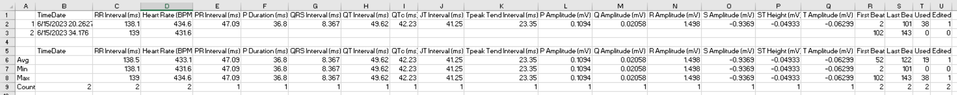

And here is an example of a transformed output **transposed** for the mouse above:

|  |  |
| --- | --- |
| ***COLUMN NAME*** | ***VALUE*** |
| Test Code | 3600684 |
| TimeDate | 2023-06-15 |
| RR Interval (ms) | 138.5 |
| Heart Rate (BPM) | 433.1 |
| PR Interval (ms) | 47.09 |
| P Duration (ms) | 36.8 |
| QRS Interval (ms) | 8.367 |
| QT Interval (ms) | 49.62 |
| QTc (ms) | 42.23 |
| JT Interval (ms) | 41.25 |
| Tpeak Tend Interval (ms) | 23.35 |
| P Amplitude (mV) | 0.1094 |
| Q Amplitude (mV) | 0.02058 |
| R Amplitude (mV) | 1.498 |
| S Amplitude (mV) | -0.9369 |
| ST Height (mV) | -0.04933 |
| T Amplitude (mV) | -0.06299 |
| First Beat | 52 |
| Last Beat | 122 |
| Used | 38 |
| Edited | 1 |
| Raw File | \\jax\jax\phenotype\EKG-V2\KOMP\images\A-15555-RAW.pdf |
| Average File | \\jax\jax\phenotype\EKG-V2\KOMP\images\A-15555-AVERAGE.pdf |

## Algorthim

Note: Columns and rows are 1-based – not zero-based.

1. Begin loop: For each import file in folder…

1. Capture the experiment barcode from the mouse name from the input filename using OData. This will be what we called in JaxLIMS the test code. Insert or append a new column for this in the output data record.

(It would be great if the barcode were in the import file.)

1. Use row 1 columns 2 through 21 as the output column headers
2. Capture the 'TimeDate' of the experiment in row 2 column 2 as *TimeDate.*
3. Capture the 'Used' from row 2 column 20
4. Use row 6 columns 3 through 21 as the values ***except for TimeDate and Used***
5. Add a column "Raw File" for the RAW file.
   1. Create raw filename : path on phenotype drive to images folder + mouse name + "-RAW" + ".pdf"
6. Add a column "Average File" for the AVERAGE file.
   1. Create average filename : path on phenotype drive to images folder + mouse name + "-AVERAGE" + ".pdf"
7. Store line of output data somewhere (list of strings?)

-> End of loop

2. For each line of data, dump it to the output file.